

**Smart City Hackathon Rajkot 2020-21**

**A Project Report On**

**Industry Type: Environment**

**Problem ID:  SCHR033**

**Problem Statement: Plant a tree app**

**Team ID: TM000079**

**Team Leader Details:   Aghera Kevin Bipinbhai**

**Faculty Details:   Niraj Bhagchandani**

**Team Members:**

1. **Aghera Kevin Bipinbhai (**[**kpatel9899s@gmail.com**](mailto:kpatel9899s@gmail.com)**)**

**Contact No. : 8140169137**

**MCA Semester - 4 , Atmiya University – Rajkot**

1. **Changela Savan Prasudbhai (**[**savan.changela273@gmail.com**](mailto:savan.changela273@gmail.com)**)**

**Contact No. : 9537839403**

**MCA Semester - 4 , Atmiya University – Rajkot**

1. **Garach Devang Bharatbhai (**[**devanggarach@gmail.com**](mailto:devanggarach@gmail.com)**)**

**Contact No. : 8460352525**

**MCA Semester - 4 , Atmiya University – Rajkot**

1. **Panara Shivang Dilipbhai (**[**shivangpanara@gmail.com**](mailto:shivangpanara@gmail.com)**)**

**Contact No. : 9106861734**

**BE in Electronic & Communication – 6, Atmiya Institute of Technology and Technology – Rajkot**

**Synopsis Abstract –**

CareTree is designed to aware and motivate citizens to grow trees ad take care of trees. For that citizens can request to NGO for sapling or plant a tree in the neighborhoods.

We build the app for that citizen can request trees from directly NGO and NGO team can accept that request and deliver the sapling to the citizen. NGO member came with Tree kit having sapling, tree caring gadget and tree protection cage. After that our app will provide all facility like water manage, damage control and same informatics notification.

If citizen don't need to plant tree but want to care the trees, For that we are provide map facalitie in our app to where the trees are damaged or having same problem. If citizen near that location they can help tree, example if tree water level down, cage damaged or other issues.

**Literature Review/Existing Innovation-technology to address related to your problem –**

There are many tree care teams available but many of that are paid, So many citizens avoid that. In the market, to check the humidity of tree and soil moisturization sensor available but it’s costly. There is no app to use the sensors and locate damaged trees.

**What would be your approach to solve the problem –**

Citizens can order sapling from NGOs and NGOs will get a grant from RMC. They provide one gadget that can check soil moisturization and humidity of tree and send data via server to the app. Citizens take care of trees easily from the app. A citizen can also care about the nearest trees of the use of our tree locate services on the map.

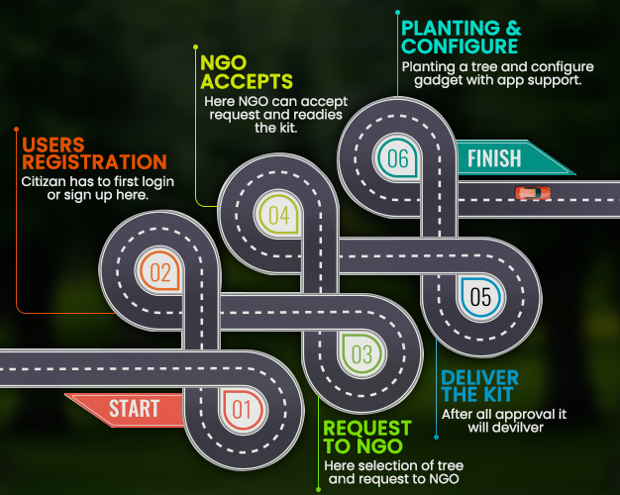**Road map/Flow diagram to develop final solution (1) –**

**Tools and technologies to be used to solve the problem –**

* Android Studio
* MySQL
* PHP
* C language
* Arduino
* NodeMCU
* ESP8266(microcontroller)
* Sensors
* at mega microcontroller chips(optional)

**Challenges/Risk in implementing your Final prototype -**

Same time weather not good and the chance to may damage gadgets, so data could not be received. If the internet is not working at that time, connectivity will be affected, and the server could not get data.

**Possible outcome of your work -**

Citizen will aware to save the environment, At RMC public place trees will we automatically care by our project, our app will help to get a sapling from NGOs and care trees by using our services.

**Work done till date -**

We have done Complete Analysis of this project, we also visited nearest nursery understand types of soils, plants, at how much humidity it required.